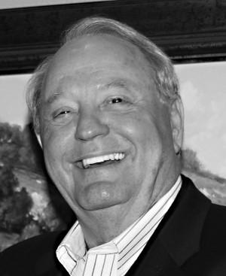
Donald Edward Vrba
(Aug. 18, 1943 - Aug. 12, 2010)

Donald Edward Vrba of Richmond, was born Aug. 18, 1943, and passed away Thursday, Aug. 12, 2010. He was born in West, Texas, and married Sandra Mikeska Vrba, Aug. 31, 1963.
"Big" Don was a loving husband, brother, father and grandfather. He was passionate about golf and enjoyed travelling the globe to play a round and shop for the latest technology in golf clubs and accessories to shave precious strokes from his game.
He is survived by his wife, Sandra; son, Donald Vrba and wife, Shannon, plus their two daughters, Chandler and Darby; daughter, Rebecca and husband, John Dugat; sister, Eva and husband Ramsey Farley; brothers, Wayne Vrba, and Pat Vrba and wife, Kathy; and numerous nieces and nephews.
Friends are cordially invited to a visitation with the family from 2 p.m. to 5 p.m. Sunday, Aug. 15, in the Jasek Chapel of Geo. H. Lewis & Sons, 1010 Bering Dr. in Houston. The recitation of the Holy Rosary will commence at 5 p.m.
The Mass of Christian Burial is to be celebrated at 11 a.m. Monday, Aug. 16, at Sacred Heart Catholic Church, 507 South Fourth St. in Richmond, where the Rev. Ralph Roberts, Pastor, is to serve as celebrant.
The Rite of Committal will follow, via an escorted cortege, in the Mausoleum at Memorial Oaks Cemetery in Houston.
http://www.memorialoaksfunerals.com

Kindy consider a memorial donation to Sacred Heart Catholic Church, 507 South Fourth St., Richmond, Texas 77469, in lieu of customary remembrances.
http://www.sacredheartrichmond.com/index.html

Arrangements have been entrusted to Geo. H. Lewis & Sons, 1010 Bering Dr. in Houston, 832-266-0711.
http://www.geohlewis.com/

