From: Gene Brumbelow
Sent: Wed 11/15/2006 5:33 PM
To: Michael Gandolfo
Subject: Junior Mints

After being the WCC in '05 and planning on defending that title in the '06 CUP, I was diagnosed with prostate cancer. On October 27, 2006 I had surgery for the removal. This was about 6 weeks prior to the scheduled Woody Cup in early December, and using humor to my advantage I decided to bring the Woody Cup with me to the hospital and take a picture to send to my good friends that loved Seinfeld stories like I did, and thus the Junior Mints.
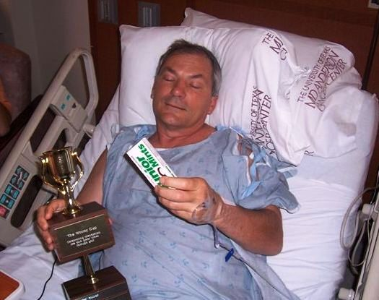
I wanted my friends to know I was going to be fine, and used the chance to make light of the situation by "clinging to my CUP", and actually just urging the guys to make sure they were ready for the CUP as that was my goal to be ready in six weeks to defend as CWCC. I did and actually did very well even though never trying a swing until #1 at the CUP. Made a lot of fun out of it, and we all used humor, as we always have, to make light of the situation.

On the 7th hole, I declared that day to be the first person in WC history to make a birdie without a prostate … a record I presume I will always own.

The build up to the '06 Woody Cup contained some of the best emails amongst all of the guys as we all contributed to GREAT MOMENTS IN WOODY CUP HISTORY!
If you do not have those emails they need to be retrieved.

A lot of the guys attended the event thinking I was dying, but I suckered them, and was sort of in the running that day as I played better due to slowing down my swing. (Although I don’t endorse this as a legitimate method for swing correction).
~Gene

