“The Shot Heard Round the 17thFairway”
-Gene Brumbelow recounts the historic shot that secured the 05’ Woody Cup

"The Shot Heard Round the 17th Fairway is as clear in my mind today as it was the 20th day of December, 2005. The 17th at Pine Dunes, a 434 yard par 4 dogleg right, narrow tree lined fairway is the #2 handicap hole and the one without a bunker. It was a slightly misting day (yet pleasant) with even a hint of Scotland, and with the fairways not over seeded, the golden grass and the pines made a beautiful course even that much more so.

The scoring system chosen awarded sixteen points per hole, and through the 16th, I held a slim margin over John Phillips. If he were to score points on 17 it would have tightened the match going into 18 which he probably would dominate as it is the easiest par 5 on the course. I did not want that to be the situation, thus winning or tying 17 would mathematically eliminate the others.
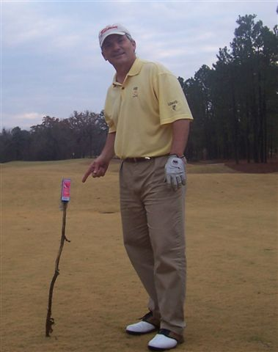
Both John and I had good drives avoiding the trees, and on that hole a straight drive is huge. John of course outdrove me, thus I was to hit first, and John began injecting thoughts into my head about the upcoming shot. I had a 205 yard shot with a 5 wood. The onslaught of doubting words was deafening as the shot was made. It took out low and rose toward the top of the pines and slightly drew toward the green where it landed some 20 feet from the pin. John was the inaugural Woody Cup champ in 2004, and a huge favorite to win, and knowing enough points was now virtually impossible the silence became deafening from Mr. P, the Current Woody Cup Champion (CWCC'04) as I easily 2 putted and accepted the accolades from the others.

John seemed so invincible and was virtually a sure bet to defend his title, thus the upset pulled off that day certainly ranks as a "Great Moment In Woody Cup History" to win the "Cup."

The trophy exchange back at the cabin on Lake Jacksonville was made with John congratulating me as the '05 CWCC along with dinner and wines. The Woody Cup grew that day a little more, and began to set up the growth toward the '06 and '07 tournaments that truly exceeded the wildest of any of our imaginations. The CUP began to truly capture the spirit of competition embodied in our motto of "Celebrating friendships, life, and great times through golf". It was so simple yet we all felt we had something special in the making, and the current years are revealing exactly that.

