From: Craig H. Heiser
Sent: Sat 6/14/2008 10:34 AM
To: MFC
Subject: (Preliminary) Competition Results
Gentleman,

After a fine lunch we conducted our first regular competition (as opposed to past Major Championships) with 5 competitors at the Tournament Course at Woodlands Country Club. 18 holes were contested following a Stableford scoring system. Mark Ingebrigtsen was deemed the Champion Golfer of the Day by earning 3 points above his quota. The winner was awarded the rotating trophy which had been introduced to the membership in a ceremony at lunch. Mark will hold the trophy until our next competition when it will be awarded to the next Champion Golfer of the Day. The MFC competition committee has deemed the trophy fit for either ceremonial display or actual match competition at the discretion of the current Champion Golfer of the Day.

Competitors celebrating a fine day of golf in the men’s locker room before the awards ceremony:
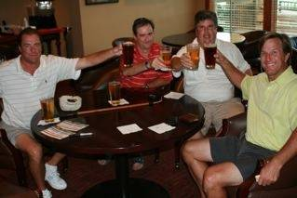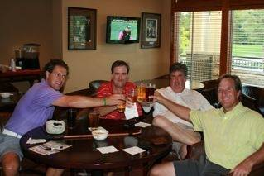

Presentation of the trophy:
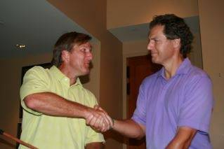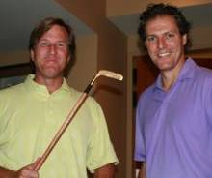

Champion Golfer of the Day, June 13, 2008 making a brief speech about the significance of becoming a champion and comparing this win to other highlights of his golf career
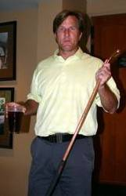

More about the trophy – MFC Chairman commissioned me to find an trophy appropriate for our membership to celebrate our competitions. After careful consideration, I selected a hickory-shafted, 24k gold plated putter handmade by Angus MacKay of Perrsyville, Ohio. “Champion Golfer of the Day” is engraved on the hickory shaft. Upon discussion yesterday we decided to regrip the club to replace the state of the art Golfpride grip with a leather wrap of some kind.

Official results of Competition #1:
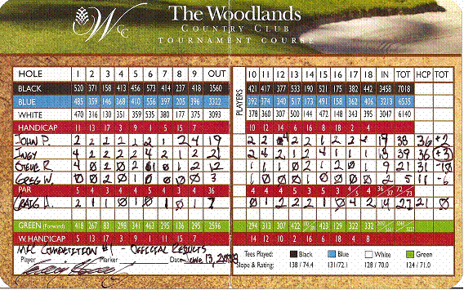

Competition Highlights:
Weather: 90 degrees with partly cloudy skies that threatened rain throughout. Mild breeze with gusts related to nearby storms. Play was never interrupted by weather, but light rain did fall occasionally which led to conditions similar to a sauna.

Key events in the competition:
- Steve Robinson raced from the first tee to make birdie, but suffered a series of PBFU’s which could not be controlled since the beverage cart was not in service Friday afternoon
- Mark Ingebrigtsen birdied the first hole with seeming ease since the first hole is really a stern par 4 for a player of his caliber
- John Phillips started with a string of dependable pars with a birdie on the 9th to put up dependable series of Stableford points
- Greg Watkins scored his first points on the challenging 3rd hole
- I began with a steady game until the fourth hole when the pressure of competition led to 2 shots into the water
- Ingy reached both par 5s on the front in 2 shots leading to birdies, including Driver then Old Man club to reach the sixth hole playing 556 yards into a prevailing southerly breeze
- At the turn, the competition had already taken its ultimate form with Ingy leading, John close behind and Steve, Craig and Greg looking for points instead of double bogeys
- The match tightened on the back 9 as John birdied 12 and Mark birdied 11 and 15. Mark, however, bogeyed the 13th when his lay-up 8 iron traveled roughly 210 yards into the lake surrounding the island green
- After fighting the “rights” all day, our PGA professionals transformed Greg Watkins into a pronounced hooker for the remainder of the round – sometimes with great result as he earned 60% of his points after the mid-round correction
- I mounted a late charge to press the leaders with a chip-in birdie on 17 (somewhat unlikely for my game)
- Mark brought the field into the match with a bogey at 17
- On 18 tee Mark had a 2 point lead over John and a 4 point lead over Craig. John and Craig found the fairway but Mark tugged his tee shot just left into light rough
- Mark failed to find the green and I hit a banana to the furthest point of the green from the pin making my chances to find the lead very remote
- John hit a nice shot (calling for it to “Stay in the air” the whole way) which finished pin high but 12 feet right of the pin
- Mark hit his chip to roughly 8 feet
- John stood over a 12 foot putt for birdie to take the lead and force Mark to hole his 8 footer for par, but missed just left giving Mark 2 putts for the victory. Mark lagged to 2 inches for a concession for victory.

Key highlights during the competition:
- The competition and scoring system was fair (even after we had to call Steve’s pro at lunch to confirm his handicap had moved up a stroke) and rewarded aggressive play as Mark narrowly defeated John on the basis of Stableford points, although John would have won a medal play event.
- Greg Watkins offered several times to trade his left nut for just one of Ingy’s towering 320 yard drives
- Craig failed to remember Steve’s wife’s name was Ellen, and thinking he meant Ellen Degeneres I made a particularly shocking comment about what it would take to get Ellen onto the golf course. Let the record show that in reference to Ellen Degeneres my comment would be both hilarious and truthful, but in reference to Mrs. Robinson it left my fellow competitors uncomfortable fearing the first MFC fist fight
- After correcting his case of the “rights” and hitting a smooth draw on 17 tee, the group decided Watkins did not need to trade his left nut but might need to let someone tug/twist instead in light of his transformation
- During the post-round ceremony we shared the locker room lounge with perhaps the most annoying member at WCC who quickly noticed John Phillips and started an uncomfortable, “What are you doing here” conversation

All in all, a very successful, challenging and fun competition. I look forward to July 18 and hope we can have a bigger group for competition #2

-Howsy

